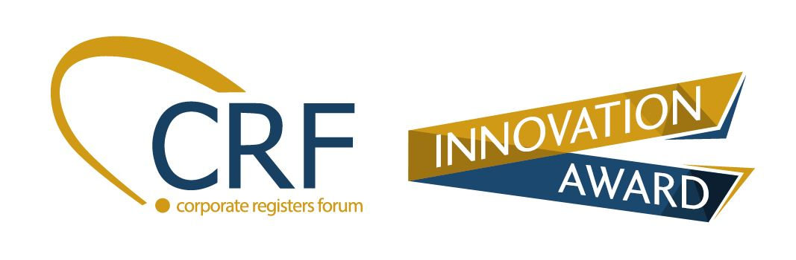

The CRF Awards recognises member jurisdictions who implement outstanding business innovation. This includes projects, products or services which make a positive difference to their stakeholders and promotes the spirit of continuous improvement.

Eligibility
• The applicant jurisdiction must be a CRF member.
• The project must be directly or indirectly related to the business of CRF members.
• The project, product or service must have already been implemented (projects in the planning stage or under development are not eligible) for a minimum period of two months prior to submission of the award application.

Instructions for submission:
- Please note that all fields must be completed. Incomplete forms will not be accepted.
- Use font, Arial Size 12 for submission.
- Keep the submission to maximum 5 pages.(Excludes Annex)
- Submit diagrams/pictures as annexes. Total attachment should not exceed 3MB.
- Submission filename taxonomies:
  - NameofOrganisation_NameofProject_ Annex_A_TitleofDocument
(e.g. CRF_InnovationProject_ Annex_A_MemberFeedback)
  - NameofOrganisation_NameofProject_ Annex_B_PhotoName
(e.g. CRF_InnovationProject_ Annex_B_AwardWinner)

Section A: Particulars of Nominee
Name of Organisation and Jurisdiction
Name  (Underline family name) | Salutation  (Mr/Ms/etc.) |  | Designation | Email Address
(Team Leader)
(Team Member)
(Team Member)
(Team Member)

Section B: Project Summary
- Share, in no more than 30 words, why you think the project is deserving of the CRF Innovative award.
- Elaborate, in no more than 300 words, what the project is about.

Section C: Project Details
Please see the evaluation criteria in Annex A.
The serves as a guide on the important aspects you should include in the award application. Please keep to no more than 500 words for each of the parts below - Part 1 to Part 4.
- Identification of Issues

Describe the existing or impending issue, challenge or opportunity that the project team sought to address.

- Innovation/Creativity

a) Describe the new idea or new approach to address the issue/challenge or opportunity ; or
b) Describe the existing solution/idea/approach that was implemented by the team to address the issue/challenge or opportunity

- Sustainability

Did the project provide a long term and sustainable intervention to address the issue/challenge or opportunity?

- Impact
- Did the project successfully address the existing or impending issue, challenge or opportunity?
- What are the key benefits that the project brought to your stakeholders? E.g. improved quality of customer service and experience, faster processing time, cuts red tape.
- Provide details of impact such as the amount of time saved, cost savings, cut down on manpower, etc.

Acknowledgement
- Send your submission for the CRF Innovation Awards by Wednesday, 30th September 2020 to CRF Secretariat at secretariat@corporateregistersforum.org and michael.brosnahan@mbie.govt.nz. Late submissions will not be considered.
- If you do not receive an acknowledgement email within 3 days of your submission, please contact Mr Michael Brosnahan at secretariat@corporateregistersforum.org for confirmation.
- ExCo’s decision shall be final. No appeals will be entertained. The winners of the CRF Innovation Awards will be notified 2 months before the CRF Conference.

- All award recipients will be required to:
- make a presentation at the upcoming CRF Conference about their project,
- submit a short write-up of their innovative initiative and a photo of their project team for publication in the quarterly CRF newsletter or other relevant publicity materials.

Annex A: Judging Criteria

Criteria | Description | Guidelines | Weighting
Originality  - Degree of creativity/innovation | - The extent to which the initiative offered fresh, new perspectives and used creative ways to address and solve problems. | - Unique and original solution that adds value to the agency’s functions  - Adoption of a new perspective when devising a solution to an existing issue  - Formulation of an innovative solution to a new issue/problem | 40
 | Or  - The idea in the initiative might not be completely new or original, but the applicant managed to apply the idea in a new way or adopted a fresh perspective. | - Creative adaptation of solutions/ideas implemented by others  - Innovative implementation of solution for different stakeholders
Sustainability of efforts | - The extent to which the initiative implemented was a long term and sustainable intervention. | - Promotes accountability of users  - Empowers internal and external stakeholders (eg provide staff or customers with tools) | 30
Impact  - Degree which it enhances efficiency and increase effectiveness | - The extent to which the idea created positive impact for stakeholders (e.g. citizens, businesses, other agencies) in qualitative terms (ie cut down on time, money, resources). | - Streamlines processes, reduces red tape, and improves coordination and other measures to increase effectiveness and efficiency.  - Improves customer satisfaction as well as efficiency/productivity of unit | 30

